28 September 2016

Changing the Change Management

A lot of projects have been failed because they denied the importance of Organizational Change Management (OCM). Nowadays we have talked about Digital Transformation, and we cannot forget how relevant is this subject that can determine the success or failure of a project. This topic is so important that the ACMP (Association of Change Management Professionals) launched recently the [Certified Change Management Professional (CCMPTM) Program](http://www.acmpglobal.org/?ccmp) and the University of New South Wales, through the Australian Graduate School of Management, offers a [Graduate Certificate in Change Management (GCCM)](https://www.business.unsw.edu.au/degrees-courses/postgraduate/graduate-certificate/change-management) to develop effective agents of change. [SAP Activate](https://roadmapviewer-supportportal.dispatcher.hana.ondemand.com/) methodology emphasized the importance of this work stream for successful cloud or on premise implementations as well.

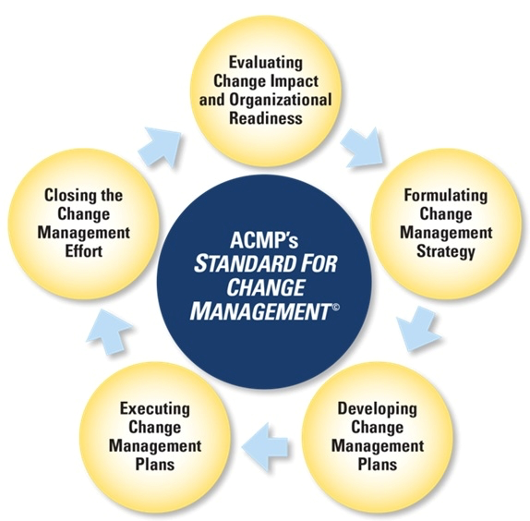

Source: <http://www.acmpglobal.org/?TheStandard>

The change control process for ICT management (project and BAU) is considered the [ALM](http://scn.sap.com/community/it-management/alm) backbone for many customers. It orchestrates, integrates and synchronises other ICT processes: process management, incident and problem management, requirement management, release management, etc. In [SAP Solution Manager 7.2](http://go.sap.com/community/topic/solution-manager.html), the user interface for ChaRM has not been changed considerably to justify a implementation or upgrade, but the new features based on SAP CRM 7.0 Enhancement Package 3 and the new **Administration Cockpit** are definitely very good reasons to evaluate SAP Solution Manager 7.2 as a Change Control tool.

Machine generated alternative text:
28 on 20's 
Task Lists 
.oocco;972 

Machine generated alternative text:
Administrator's Cockpit unites all key information in a central place 
Transport 
Overview 
CSOL Data 
Landscape 
Overview 
"Tracking 
Fulltext 
Search 
Task List 

Changes might have high impacts on users and analysts daily activities, so it is important to communicate, train and empower all stakeholders to have a successful process and tool adoption. Most of the companies prefer to implement Change Control Management through a phased approach instead of the big-bang. Therefore, to maximise the value of Change Control Management within SAP Solution Manager and to implementing features gradually to step up the maturity and governance level, you might follow this roadmap:

1. Two-Speed IT, balancing Continuity and Innovation with cCTS - Central Change and Transport System
2. Reduce manual effort through integration with CTS/CTS+ - Enhanced Change and Transport System
3. Retain the overview and obtain the benefit from increased transparency with TEA - Transport and Execution Analysis - and Change Diagnostics
4. Introduce central transport control without risking consistency and flexibility with Retrofit
5. Establish a common quality process across technology stacks with QCM - Quality Gate Management
6. Full change traceability with built-in safety assurance for your IT infrastructure with ChaRM - Change Request Management
7. Provide an integrated and collaborative Requirements to Deploy Process for Business and IT with the new Release Management capabilities

Machine generated alternative text:
NEW 
Rel ease 
Management 
Change Request 
rvhnagement 
Quality Gate 
rvhnagement 
Central Transport 
rvhnagement 
Retrofit 
Change and Transport 
system (SAP 1 Non SAP) 
Transport 
Analytics I 
Change 
Diagnostics 

Machine generated alternative text:
SAP Solution Manager 7.2 
Dual Landscape 
Synchronization 
(Retrofit) 
EA 1 Change 
Diagnostics 
Change Request 
Management 
Release Management 
Change Request 
Management 
Quality Gate 
Management 
Central Transport Management 
CTS 1 CTS* 

If RevTrac is implemented, this is a tool to be compared with [CTS+ (Enhanced Central and Transport System)](https://wiki.scn.sap.com/wiki/pages/viewpage.action?pageId=448469096). Then, RevTrac covers only the technical layer, and it must be integrated with a Service Desk tool, such as ServiceNow, Remedy, Service Manager, Qualitor, Jira, Assyst, etc. We could reduce TCO by implementing SAP Solution Manager 7.2, which includes a complete Service Management tool plus a transport management tool for SAP and non-SAP systems. Run for it!

--

Jacques K. Maeda

[www.linkedin.com/in/jkmaeda](http://www.linkedin.com/in/jkmaeda)